Part B Design Report Team232

Xavier Andueza,

Ritchie Leong,

Ling Chen,

Kabir Chugh,

Jason Ung,

John Nguyen

Contents

1. Design Features 3

1.1 Handle/Grip 3

2. Calculations and Assumptions 3

2.1 Mass of the device 3

2.1.1 Mass of components 3

2.1.2 Size of the flask 3

2.1.3 Mass of Anaerobic Digestate (AD) 3

2.2 Weight of the device 3

2.3 Servomotor and Rotating platform 3

2.3.1 Turning speed of rotating platform 3

2.3.2 Angular control 4

3. Simulations 4

3.1 Handle/Grip 4

4. Physical Experiments 6

4.1. Camera Testing 6

4.1.1. Background Removal Testing 6

4.1.2. Image Resolution Testing 6

4.1.3. Algorithm Detection Robustness and Accuracy 7

4.2 Servomotor Testing 8

4.2.1 Range of rotation 8

4.2.2 Varying speed and varying load 9

# 1. Design Features

## 1.1 Handle/Grip

One of the main features in our design is the handle. The handle allows the device to be carried around by the user. When held by the user, the handle is the most critical part supporting the weight of the whole device. Thus, we have analysed the handle by running FEA simulations to find the stresses and displacement of the handle.

# 2. Calculations and Assumptions

## 2.1 Mass of the device

### 2.1.1 Mass of components

* Tester device (derived from Solidworks) without the 10mm solenoid valve, Pi camera, Raspberry Pi 4, White LED strips, and battery is 2964.87g
* Two 10mm solenoid valve is 4.5g X 2 = 9g
* Two Pi camera is 3g X 2 = 6g
* Raspberry Pi is 46g
* 0.05m LED strips (3 LEDs) is
* Battery is 57g

Total mass of the device is

We analyse for the system at full volume of Anaerobic Digestate.

### 2.1.2 Size of the flask

The inner glass tube has an inner diameter 5cm (radius 2.5 cm) and height 10cm

The volume of the flask

### 2.1.3 Mass of Anaerobic Digestate (AD)

The density of AD is approximately

The maximum amount of AD allowed in the system is

## 2.2 Weight of the device

When the glass is fully filled with AD, the total weight of the device is

## 2.3 Servomotor and Rotating platform

## 2.3.1 Turning speed of rotating platform

The servomotor rotates at a max operational speed and has a maximum range of 180°. To calculate the angular velocity in units of rad/s is as follows, where **θ** is how range of rotation in degrees, and **t** is time to reach said rotational angle in seconds.

## 2.3.2 Angular control

From the gpiozero library, provided code details how the servomotor rotates. “servo.min()” rotates the servo to starting position or 0°. “servo.mid()” rotates to 90° or midway and “servo.max()” rotates to end position or 180°.

Another way to control the position of the servo is by setting the value of the servomotor using the line of code: “servo.value = x”, where x is a real number between –1(min) and 1(max). This implies that a value of –1 corresponds to 0°, 0 corresponds to 90° and 1 corresponds to 180°. From this a function was created whereby a user enters a value between 0° and 180°. **θ** is in angle of rotation in units of degrees.

However, because in Python, a math library is required to access these tools, the function is more accurately as follows:

# 3. Simulations

## 3.1 Handle/Grip

The weight (32.2N) of the device acting on the handle is used in the FEA simulation to find the stresses and displacement of the handle.

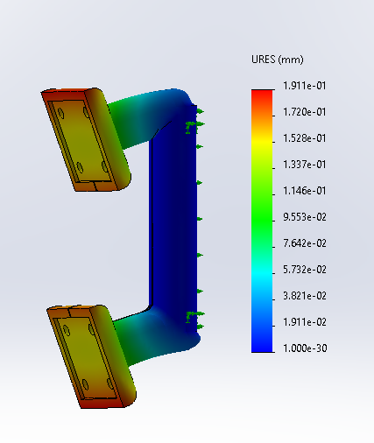

Figure 1: FEA displacement of handle and grip

Through FEA simulation, the max displacement of the handle (shown in Figure 1) is on the rubber grip. The max displacement is approximately 0.19mm, which is acceptable since the material is rubber. The max displacement on the plastic (ABS) handle itself is around 0.15mm and is negligible.

Figure 2: FEA stress of handle and grip

Through FEA simulation, the max stress (shown in Figure 2) experienced by the plastic handle is approximately 1.37MPa. The maximum allowed stress for ABS is 315MPa. So, the safety factor of the handle design is 230. Thus, we are very confident that the handle design will not fail, it is very safe.

# 4. Physical Experiments

## 4.1. Camera Testing

The proposed design of our device heavily relies on the reliability of the camera image analysis. It is the core functionality of the device and is crucial to the successful extraction of anerobic digestate information. The thorough tests in the following sub-sections are done to help determine and justify key design features needed to assist the functionality of the image analysis algorithm.

### 4.1.1. Background Removal Testing

Background removal is the first step needed in the analysis process; hence it is crucial to ensure successful background removal. The following Figure X

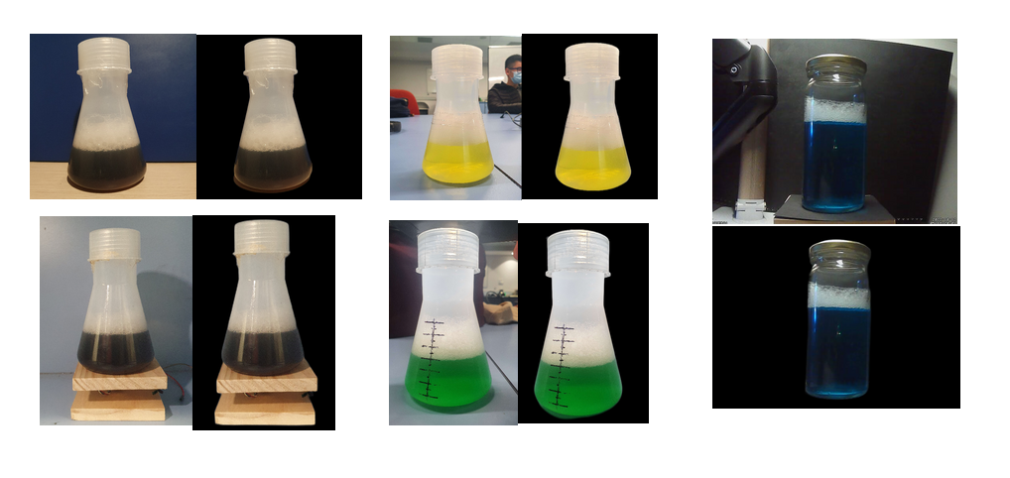

Figure 3:Background removal tests

As seen from Figure X, the background can be successfully removed in most environments, however there are still some cases where the useless and interfering objects remain in the image after removal. Therefore, to combat this problem in the design, we ensure that the glass tube containing the flask is completely sealed by an outer casing where the inside is painted black. This would completely remove the chance of unwanted background interference.

Furthermore, the background removal AI (Artificial Intelligence) is designed in a way where ideally the object of interest should be somewhere in the middle of the camera frame. In this design this is accounted for by keeping the anerobic digestate in a central glass tube and having the cameras pointed directly at it.

### 4.1.2. Image Resolution Testing

The image resolution test was done to determine the minimum required camera resolution that was needed to achieve accurate extraction of key information in the image. Using this information an appropriate camera suited for the purpose can be selected. Another small consideration was the running time of the code. The testing results are shown in Figure X below.

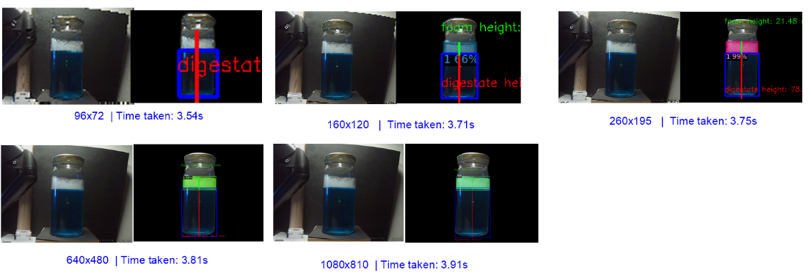

Figure 4:Camera resolution tests

Several conclusions can be drawn from the above Figure. Firstly, the tests demonstrate that foam and digestate regions can be accurately detected even with small resolution of 160x120, however it fails at resolutions below that due to too much loss of information. Another thing is that the lower the resolution, the more error the height measurements will be, as there are simply less pixels hence much larger height increments.

Another observation is that the running time of python scripts are similar despite the increase of resolution. This is due to the running time being primarily dominated by the loading of the neural network model weights. However, this test was done on a computer much more powerful than the raspberry pi, hence the actual running time may be longer.

Taking all of these into account, it was determined that 640x480 resolution is the best suited resolution that would reliably work with the algorithm without the loss of too much information. This also allows the design to be suited with a cheaper and lighter camera.

### 4.1.3. Algorithm Detection Robustness and Accuracy

To ensure that the detection algorithm is robust and accurate enough to use on digestate and foam of any colour and amount, thorough testing has been conducted on simulated samples of different colours and amounts. The figure below shows some tests done:

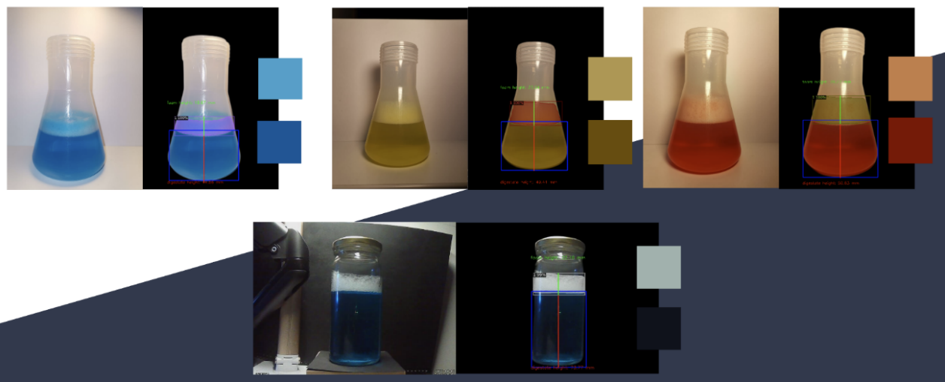

Figure : Varying Colour Tests

The results of these tests are summarised in the table below:

Table : Error Table

|  |  |  |  |  |  |  |
| --- | --- | --- | --- | --- | --- | --- |
| **Test Sample** | **Detected Foam Height (mm)** | **Actual Foam Height (mm)** | **%Error** | **Detected Digestate Height (mm)** | **Actual Digestate Height (mm)** | **%Error** |
| Light Blue | Less Foam | 19.31 | 17 | 13.59 | 42.26 | 42 | 0.62 |
| Light Blue | More Foam | 25.61 | 25 | 2.44 | 48.92 | 46 | 6.35 |
| Black | Less Foam | 20.39 | 19 | 7.32 | 44.12 | 43 | 2.60 |
| Black| More Foam | 29.4 | 27 | 8.89 | 45.56 | 44 | 3.55 |
| Green | Less Foam | 18.99 | 19 | 0.05 | 51.96 | 50 | 3.92 |
| Green | More Foam | 28.92 | 29 | 0.28 | 50.06 | 48 | 4.29 |
| Red | Less Foam | 19.23 | 17 | 13.12 | 48.44 | 46 | 5.30 |
| Red | More Foam | 26.93 | 27 | 0.26 | 51.79 | 50 | 3.58 |
| Yellow | Less Foam | 16.66 | 16 | 4.13 | 50.22 | 50 | 0.44 |
| Yellow | More Foam | 26.32 | 26 | 1.23 | 50.25 | 50 | 0.50 |
| Orange | Less Foam | 17.74 | 17 | 4.35 | 51.55 | 50 | 3.10 |
| Orange | More Foam | 25.3 | 24 | 5.42 | 51.09 | 50 | 2.18 |
| **Average:** |  |  | **5.09 %** |  |  | **3.04%** |

As seen from the results above, the average error is around 3-5% which is acceptable for our design, however there were some images where error went as high as 13%. These cases of higher error are due to incorrect camera angles. When the camera angle is not directly perpendicular to the foam level line, it causes the side of the foam to appear taller in the camera than the centre of the foam, which causes errors in the foam bounding box detection. Another issue is the parallax error.

To minimise this, in the design the camera is placed directly facing the centre of the glass tube, and the amount of digestate in the device required for analysis will be consistent, hence the camera will always be pointed at the foam level, which helps to minimise the errors discussed above.

## 4.2 Servomotor Testing

## 4.2.1 Range of rotation

There exist many types of servomotors, which are characterized by their rotational behaviour. A continuous rotation servo is a servomotor that can rotate continuously in either direction for as long as the user desires. Speed of rotating and time rotating can be controlled. A linear servo is a servomotor that does not rotate but moves back and forth like a rack and pinon system. A positional rotation servo is a servomotor that is limited a range of roughly 180°. Only the position of the servo can be controlled. The positional rotation type servomotor was utilized in this project.

The gpiozero library was employed to allow rotational control of the servo. The minimum pulse width and maximum pulse width values are essential in determining the maximum range of rotation. Within the data sheet of servomotors contains the standard minimum and maximum pulse width values. However, as all servomotors are not built the same, these values are merely suggestions, and the true bounds of the range of rotation must be experimentally determined. It was found that at a minimum pulse width value of 0.5 milliseconds and a maximum pulse value of 2.33/1000 seconds satisfies the bounds of 180° rotation.

## 4.2.2 Varying speed and varying load

By varying the speeds and the load on the platform, we can identify patterns that could not have been clearly identified.

Modes of speed include - Slow, medium, fast and max speed.   
Weight of loads include - No load, 100ml filled flask, 200ml filled flask and 300ml filled flask.

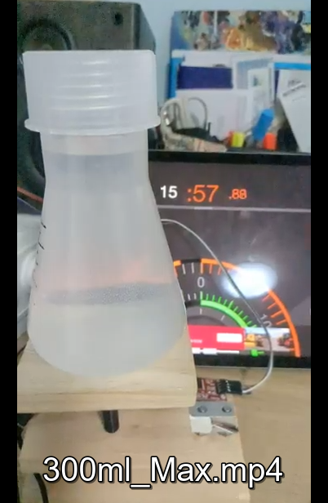

Figure 6: Flask with water on load cell

By placing a timer in the background, where its format includes milliseconds, we can use a x8 slow motion camera to measure the time taken to rotate to a specific angle. Through thorough testing and frame-by-frame analysis, we have obtained many samples and identified many relationships.